Working document
COMMISSION DELEGATED REGULATION (EU) No XX/YYYY
of [date]
supplementing Directive 2010/30/EU of the European Parliament and of the Council with regard to online energy labelling of energy-related products
(Text with EEA relevance)

THE EUROPEAN COMMISSION,
Having regard to the Treaty on the Functioning of the European Union,
Having regard to Directive 2010/30/EU ..,

Whereas:

(1) …

HAS ADOPTED THIS REGULATION:

Chapter 1
Subject matter

1. This Regulation establishes requirements for the online energy labelling and the provision of supplementary product information for energy-related products.

2. This Regulation shall apply to energy-related products obliged to display the energy label by a delegated act / any implementing act under Directive 2010/30/EU.

3. This Regulation shall not apply to:

(a) auction sites;
(b) second-hand products.

Chapter 2
Definitions

In addition to the definitions laid down in Article 2 of Directive 2010/30/EU, the following definitions shall apply:

(1) ‘auction site’ means an internet site where the members of the public offer for sale, purchase, trade or barter goods;
(2) ‘online selling’ means the act of presenting for sale, hire or hire-purchase through the Internet which implies that the potential end-user cannot be expected to see the product displayed;
(3) ‘e-commerce’ means commercial transactions conducted either wholly or partially on the Internet;
(4) ‘energy label’ means the product specific label set out in a given delegated act under Directive 2010/30/EU;
(5) ‘internet’ means the worldwide and interconnected computer systems and communications network;
(6) ‘nested display’ means visual interface where an image or data set is accessed by mouse click, mouse roll-over or tactile screen expansion of another image or data set;
(7) ‘online advertisement’ means any advertisement on the Internet for a specific model of an energy-related product covered by a delegated act under Directive 2010/30/EU provided that energy-related or price information is disclosed;
(8) ‘online environment’ means all sites and services available on the Internet;
(9) ‘online technical promotional material’ means any material, namely technical manuals and manufacturers’ brochures on the Internet which describes the specific technical parameters of an energy-related product covered by a delegated act under Directive 2010/30/EU;
(10) display mechanism means any screen, tactile screen or any new visual technology used for displaying internet content to users on any existing or new device
(11) ‘standard screen’ means the display mechanism of any device that can be connected to the internet;
(12) ‘tactile screen’ means touch screen of a device such as a tablet or a smartphone;
(13) ‘technical documentation’ means documentation containing the information referred to in Article 5(b) of Directive 2010/30/EU;
(14) ‘web accessibility’ means special provision made for the sight impaired to access and use Internet based content.
(15) 'cost of ownership' means the total cost of purchasing and operating a product over its lifetime including use of resources other than energy

Chapter 3
Responsibilities of suppliers

1. Suppliers shall ensure for the purposes of distance selling that:

(a) an energy label is made available electronically for a product placed on the market or put into service and covered by a delegated act under Directive 2010/30/EU;
(b) a product fiche is made available electronically;
(c) any online advertisement for a specific model of an energy-related product covered by a delegated act under Directive 2010/30/EU contains the energy efficiency class if the advertisement discloses energy-related or price information;
(d) any online technical promotional material concerning a specific model of an energy-related product covered by a delegated act under Directive 2010/30/EU, which describes its specific technical parameters, includes the energy efficiency class of that model; and
(e) Web accessibility is provided for the sight impaired as governed by relevant EU legislation.

2. Suppliers may use the following means to provide the energy label and product fiche:

(a) a website where they can be downloaded by dealers;
(b) email on request of the dealer;
(c) placing a data storage device inside the packaging box of the appliance;
(d) sending a storage device by ordinary mail.

Chapter 4
Responsibilities of dealers

1. Dealers shall ensure for the purposes of distance selling that:

(a) each product covered by a delegated act under Directive 2010/30/EU and made available for e-commerce on-line bears the energy label provided by suppliers in accordance with Chapter 3(1) on the display mechanism in a clearly visible and legible format. It shall appear in proximity to the price of the product and in a font size equivalent to that of the price. If the label is displayed using a nested display, the image used for accessing the label shall be the energy efficiency class of the product using the corresponding colour of the energy label for that class. The full label shall present on first mouse rollover or tactile screen expansion;
(b) each product covered by a delegated act under Directive 2010/30/EU and made available for e-commerce on-line is marketed with the product fiche provided by suppliers in accordance with Chapter 3(1)(b) on the display mechanism in a clearly visible and legible format in proximity to the price of the product and the energy efficiency label or class image and in a font size equivalent to that of the price. If the information is displayed using nested display, the image used for accessing the fiche shall clearly refer to the content of the information;
(c) any online advertisement for a specific model of an energy-related product covered by a delegated act under Directive 2010/30/EU contains the energy efficiency class if the advertisement discloses energy-related or price information;
(d) any online technical promotional material concerning a specific model of an energy-related product covered by a delegated act under Directive 2010/30/EU, which describes its specific technical parameters, includes the energy efficiency class of that model;
(e) Web accessibility is provided for the sight impaired as governed by relevant EU legislation.

2. The appropriate sizing, aspect ratios and the sequence of display that adhere to existing device conventions for nested displays and magnification are set out in the Annex.

3. Dealers may also provide the following for the purposes of distance selling:

(a) a check box acknowledging that the customer has seen the label and the fiche before proceeding to payment;
(b) a tool providing total cost of ownership;
(c) a tool enabling comparison between products;
(d) a product search tool with filters for the energy efficiency class or any other information displayed on the energy label.

Chapter 5
Market surveillance

Member States shall regularly monitor compliance with this Regulation with special regard to the responsibilities of suppliers and dealers.

Chapter 6
Revision

The Commission shall review this Regulation in the light of technical progress in the online environment no later than 5 years after its entry into force.

Chapter 7
Transitional provision

Chapter 3 and Chapter 4 shall not apply to distance selling, e-commerce, online advertisements and online technical promotional materials published before [insert date – 6 months after the entry into force of this Regulation].

Chapter 8
Entry into force

This Regulation shall enter into force on the 20th day following its publication in the Official Journal of the European Union.

It shall apply from [insert date – 6 months after the entry into force of this Regulation].

This Regulation shall be binding in its entirety and directly applicable in all Member States.

Done at Brussels, [date].

For the Commission
The President
José Manuel BARROSO
ANNEX

Nested display and magnification

1. To ensure on screen legibility for displaying the energy efficiency class providing access to the energy label, the energy efficiency class shall be displayed in one of the following four orientations and sizing in proximity to the price of the product and in a font size equivalent to the price:

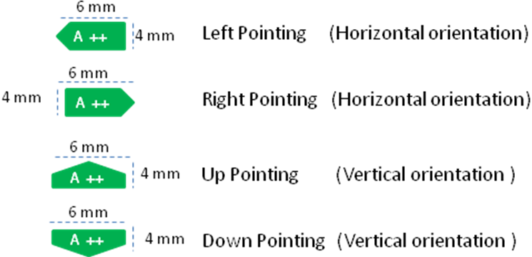

2. The sequence of display of the on-screen energy label for standard screens shall be as follows:
- the display of energy class shall be presented to the end-user at the first and subsequent instances of showing product price information;
- the energy class image shall be linked to a graphic of the full energy label;
- the full energy label shall be displayed by mouse roll-over or mouse click on the energy class image;
- the display of label shall be done either by: pop up; new tab; new page; or inset screen display;
- stopping the display of the label shall be done by close option or standard closing mechanism;
- the alternative text for the graphic to be displayed on failure to display the energy label shall be the energy efficiency class as denominated on the full label for the product displayed and in a font size equivalent to that of the price.
3. The sequence of display of on-screen energy label for tactile screen devices shall be as follows:
- the display of energy class shall be presented to the end-user at the first and subsequent instances of showing product price information
- the energy class image shall be linked to a graphic of the full energy label;
- the full energy label shall be displayed by tactile screen expansion and device conventions for magnification shall apply;
- the display of label shall be done either by: pop up; new tab; new page; or inset screen display;
- stopping the display of the label shall be done by close option or standard closing mechanism;
- the alternative text for the graphic to be displayed on failure to display the energy label shall be the energy efficiency class as denominated on the full label for the product displayed and in a font size equivalent to that of the price.

